SHRI KRISHNASWAMY COLLEGE
FOR WOMEN AI-AUGMENTED BACKEND DEVELOPMENT

AI FITTRACK API
PROJECT DOCUMENTATION
ROLE | NAME | REGISTER NUMBER
Team Leader | PRIYADARSHINI D | 222409074
Team Member | MUBASSHIRA FATHIMA M | 222409063
Team Member | MAYHAK ASHITHA R | 222409061
Team Member | SOUNDARYA SV | 222409093
TN SKILLS

1. ABSTRACT
AI FitTrack is an AI-assisted fitness management system designed to help users organize their exercise activities and understand their progress through structured digital records. The proposed system combines secure user accounts, workout scheduling, activity logging, progress summaries, and AI-generated fitness guidance in a single backend application.
Unlike a simple workout diary, the system transforms stored activity data into useful summaries. Users can record exercise type, duration, intensity, calories burned, and workout date. The application can provide weekly summaries and personalized suggestions based on the information supplied by the user. The project emphasizes secure data handling, modular backend development, RESTful APIs, and AI integration.

2. INTRODUCTION
Regular exercise creates a large amount of personal activity information. When this information is maintained only in notebooks or scattered applications, it becomes difficult to identify progress and maintain a consistent history. AI FitTrack provides a centralized digital solution for recording and reviewing fitness activity.
The backend accepts requests from a web application, mobile application, or API testing tool through REST APIs. It validates requests, authenticates users, stores workout information, and communicates with an AI service when intelligent recommendations are requested.

3. PROBLEM STATEMENT
Common issues include inconsistent manual entries, difficulty finding older workout information, lack of structured progress summaries, and uncertainty about which activities may suit a stated fitness goal. A digital fitness backend addresses these issues through consistent storage, authentication, search, filtering, summaries, and general AI-assisted recommendations.

4. OBJECTIVES
- Create a centralized platform for fitness activity records.
- Provide secure registration and login.
- Store workout information in a structured database.
- Support create, read, update, and delete operations.
- Allow users to search their workout history.
- Generate weekly activity summaries.
- Provide AI-assisted workout suggestions based on user-provided information.
- Produce fitness insights from recorded statistics.
- Maintain a modular and scalable backend architecture.
- Validate requests and return clear JSON responses.

5. EXISTING SYSTEM
In a manual system, users commonly record workouts in notebooks, spreadsheets, or unrelated applications. Such methods can work for small amounts of information but become difficult to maintain over time. Repeated manual calculations for total duration, workout frequency, or calories can be inconvenient, while searching and updating historical entries becomes harder as records increase.

6. PROPOSED SYSTEM
The proposed AI FitTrack system stores user and workout information in a centralized MongoDB database. Node.js and Express.js provide the server and API layer, while Mongoose manages database schemas and operations. An AI assistance layer accepts fitness goal, experience level, and selected activity information and can return structured suggestions, training reminders, and general progress observations. Authentication and authorization are applied before protected records are accessed.

7. KEY FEATURES
- User registration and secure login.
- Profile retrieval for authenticated users.
- Workout creation with date, category, duration, and calories.
- Workout history retrieval, update, and deletion.
- Search by name, category, or date.
- Weekly activity summary.
- AI-based recommendation service.
- AI-generated progress observations.
- Validation and centralized error handling.
- JSON-based REST API responses.
- Modular project structure for future extensions.

8. TECHNOLOGY STACK
Frontend/API Consumer: React, mobile application, or Postman
Backend: Node.js + Express.js
Database: MongoDB
ODM: Mongoose
Authentication: JSON Web Token (JWT)
Password Security: bcrypt.js
Configuration: dotenv
API Testing: Postman / Thunder Client
AI Service: Google Gemini through a dedicated service layer
Development: Visual Studio Code

9. SYSTEM REQUIREMENTS
Software: Windows/macOS/Linux, Node.js 16+, npm 8+, MongoDB, code editor, Postman/Thunder Client. Hardware: Intel Core i5 / AMD Ryzen 5 or equivalent, minimum 8 GB RAM, at least 1 GB free project workspace, and stable network access when using the external AI service.

10. SYSTEM ARCHITECTURE
AI FitTrack uses a layered architecture. The client sends an HTTP request to the Express server. The request is mapped to a route and, when necessary, passes through authentication middleware. Controllers validate the request and call the appropriate service or model. Mongoose models communicate with MongoDB. AI-related requests are forwarded to a dedicated AI service layer. The response is converted into a standardized JSON response and returned to the client.
Client | → | Express  Server |  |  | → | Routes |  |  | → | Middleware |  | → | Controllers
Services / Models |  |  | → | MongoDB |  |  | → | AI Service
Architecture Flow: Client → Express Server → Routes → Middleware → Controllers → Services/Models →
MongoDB or AI Service → Standard JSON Response → Client

PROJECT OUTCOMES
- Centralized digital fitness records.
- Secure user-specific access to workout data.
- CRUD, search, summaries, and structured fitness insights.
- AI-assisted general recommendations from user-provided context.
- Modular backend that can support web, mobile, or API clients.
- Clear validation and standardized JSON responses.

11. AUTHENTICATION AND SECURITY
A user creates an account with an email and password. During registration, the password is hashed before storage. During login, the supplied password is compared with the stored hash. After successful authentication, a JWT can be issued. Protected requests include the token in the Authorization header, and middleware verifies the token before allowing access to secured routes. Environment variables protect database connection strings, JWT secrets, and AI API keys.

12. DATABASE DESIGN
The database contains two primary entities: User and Workout. User fields include a unique identifier, name, email, encrypted password, creation timestamp, and update timestamp. Workout fields include a unique identifier, user reference, workout name, category, duration, calories burned, workout date, creation timestamp, and update timestamp.
The relationship is one-to-many: one authenticated user can own multiple workout records. Each workout record refers to the user who created it.
USER | 1 | owns | M | WORKOUT
userId name email  passwordHash createdAt updatedAt |  |  |  | workoutId  userId (FK)  workoutName category  duration  caloriesBurned  workoutDate createdAt updatedAt

Entity Relationship (ER) Diagram
USER 1 ■■■■■■■■■■■■■■■■ M WORKOUT
One User can have many Workout records; every Workout belongs to one User through userId.

DATA LAYER
Controller | → | Service / Mongoose Model | → | MongoDB Collections
The data layer separates request handling from database operations. Mongoose schemas define the structure and allow the backend to create, retrieve, update, and delete workout records while maintaining the User–Workout relationship.

13. API DESIGN
Authentication endpoints
POST /api/auth/register POST /api/auth/login GET /api/auth/profile

Workout endpoints
POST /api/workouts GET /api/workouts GET /api/workouts/:id PUT /api/workouts/:id DELETE /api/workouts/:id GET /api/workouts/search

AI endpoints
POST /api/ai/recommendation POST /api/ai/insights
All protected operations should validate the authenticated user's identity before accessing personal workout data.

14. WORKOUT MANAGEMENT
A user can create a record after completing an activity. The record can contain workout name, category, duration, calories burned, and workout date. The user can retrieve history, open a single record, edit incorrect information, delete an unwanted record, and search specific activities.
Register
→
Login
→
JWT Token
→
Create
Workout
→
Validate
→
Save in
MongoDB

VALIDATION RULES
- Workout name is required.
- Workout category is required.
- Duration must be a positive value.
- Calories burned cannot be negative.
- Workout date must be valid.
- Duplicate email addresses must be rejected during registration.
- Protected endpoints require a valid JWT.
- Missing or malformed request fields return clear validation errors.
- Invalid record IDs should return a controlled error response.

USER FLOW DIAGRAM
View / Search History | → | Update / Delete | → | AI Request | → | Structured Response

15. AI RECOMMENDATION MODULE
The AI recommendation module converts user-provided fitness context into general workout suggestions. Example inputs include age group, fitness goal, experience level, preferred activity, and available workout time. The backend prepares a controlled prompt and sends it through the AI service layer. The returned response can contain a weekly activity outline, exercise suggestions, progression ideas, and general safety reminders.
The AI output should be treated as general guidance. It should not be presented as a medical diagnosis or as a replacement for advice from a qualified professional.

AI FITTRACK RECOMMENDATION DIAGRAM
User Fitness Context | → | Backend Validation | → | Controlled Prompt
AI Service / Gemini | → | Recommendation  Response | → | User
Input examples: fitness goal • experience level • preferred activity • available time • age group
Output examples: weekly activity outline • exercise suggestions • progression ideas • general safety reminders

16. FITNESS INSIGHT MODULE
The fitness insight module analyzes stored workout statistics rather than relying only on a single activity. Example inputs include total workouts, average duration, total calories burned, and activity categories. The module can produce a concise progress summary, identify changes in workout frequency, and suggest areas that the user may want to review.

FITNESS INSIGHTS DIAGRAM
Workout History | → | Statistics Aggregation | → | Insight Analysis | → | Fitness Insights

FITNESS INSIGHTS – DETAILED FLOW
Stored Data | Calculated Metrics | Generated Insight
Workout date, category, duration, calories | Total workouts, average duration, total calories, category frequency | Progress summary, frequency changes, areas to review

DEMO VIDEO
Demo Video Link: PASTE YOUR DEMO VIDEO LINK HERE
The final submission can replace the placeholder above with the actual demonstration-video URL.

17. PROJECT WORKFLOW
- Step 1: User registration.
- Step 2: Secure login.
- Step 3: JWT token generation.
- Step 4: Authenticated request to create a workout.
- Step 5: Server validates the request.
- Step 6: Workout is stored in MongoDB.
- Step 7: User retrieves or searches workout history.
- Step 8: User submits fitness context to the AI recommendation endpoint.
- Step 9: AI service processes the request.
- Step 10: Backend returns a structured response.
- Step 11: Fitness statistics can be submitted for an insight report.

18. TESTING AND VALIDATION
API testing should cover successful requests as well as invalid inputs. The following validations keep the application behavior predictable and make errors clear to the API consumer.

AUTHENTICATION TEST CASES
- Register with valid information.
- Reject duplicate email addresses.
- Login with correct credentials.
- Reject incorrect credentials.
- Reject protected requests without a valid token.

WORKOUT TEST CASES
- Add a valid workout.
- Reject missing required fields.
- Retrieve all workouts.
- Retrieve a specific workout.
- Update a workout.
- Delete a workout.
- Search workout history.

AI TEST CASES
- Send valid recommendation input.
- Verify a structured response.
- Handle missing input.
- Handle an unavailable AI service gracefully.

ERROR RESPONSE VALIDATION
Condition | Expected behavior
Missing required field | 400-style validation response with clear message
Invalid credentials | Authentication failure response
Missing / invalid JWT | Protected route access rejected
Invalid workout ID | Controlled not-found / validation response
AI service unavailable | Graceful error response without crashing the server

19. ADVANTAGES AND LIMITATIONS

Advantages
- Centralized fitness records.
- Secure user-specific access.
- Faster workout searching.
- Reduced manual calculations.
- Modular backend architecture.
- AI-assisted personalization.
- Easy integration with web or mobile clients.

Limitations
- AI responses depend on the quality of user-provided information.
- External AI service availability can affect recommendation requests.
- The system is not a medical diagnosis tool.
- Production deployment would require additional monitoring, rate limiting, backups, and security hardening.

20. FUTURE ENHANCEMENTS
- Nutrition tracking.
- BMI and body-measurement history.
- Wearable-device integration.
- Reminder notifications.
- Exercise libraries.
- Progress dashboards.
- Achievement badges.
- More advanced analytics.
- Role-based administration for system monitoring.
- Expanded AI analysis for long-term activity patterns with appropriate safety and privacy controls.

SCALABILITY DIRECTION
Current Backend | → | Additional Modules | → | Web / Mobile Clients | → | Advanced Analytics

21. CONCLUSION
AI FitTrack provides a structured backend approach for digital fitness management. The system combines REST APIs, secure authentication, MongoDB storage, workout CRUD operations, search, and AI-assisted guidance.
The modular design separates routing, authentication, controllers, services, database models, and AI communication. This separation makes the project easier to test and extend. The proposed system demonstrates how backend development and AI services can be combined to create a practical fitness-tracking application while keeping user data organized and protected.

22. REFERENCES AND PROJECT RESOURCES
- Primary project reference: AI FitTrack API documentation supplied for this project.
- Node.js documentation.
- Express.js documentation.
- MongoDB documentation.
- Mongoose documentation.
- JSON Web Token documentation.
- Postman documentation.
- Google Gemini API documentation.

APPENDIX – SAMPLE API TEST CASES
Module | Request | Validation / Expected result
Auth | POST /api/auth/register | Valid data accepted; duplicate email rejected
Auth | POST /api/auth/login | Correct credentials accepted; incorrect credentials rejected
Workout | POST /api/workouts | Required fields and numeric/date values validated
Workout | GET /api/workouts | Authenticated user's workout history returned
Workout | PUT /api/workouts/:id | Existing record updated after identity check
Workout | DELETE /api/workouts/:id | Authenticated user's selected record deleted
AI | POST /api/ai/recommendation | Valid context returns structured recommendation
AI | POST /api/ai/insights | Stored statistics can be converted into insight summary

23. DATABASE CONFIGURATION — db.js
MongoDB connection configuration using Mongoose. This implementation corresponds to the database layer and MongoDB technology described in the documentation.
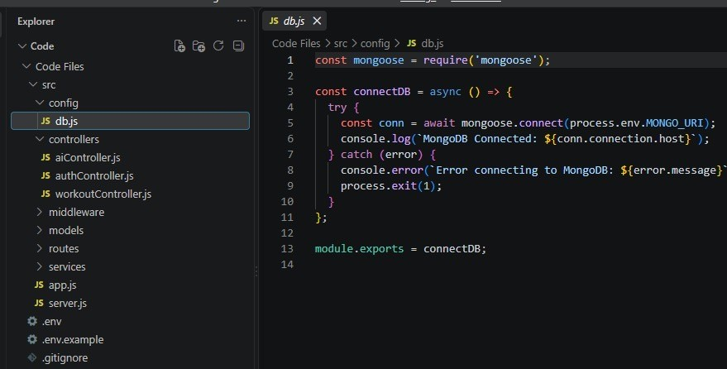
Implementation evidence supplied from the project workspace screenshots.

24. SERVER SETUP — server.js
Express server startup, environment configuration, database connection, port setup, and unhandled-rejection handling.
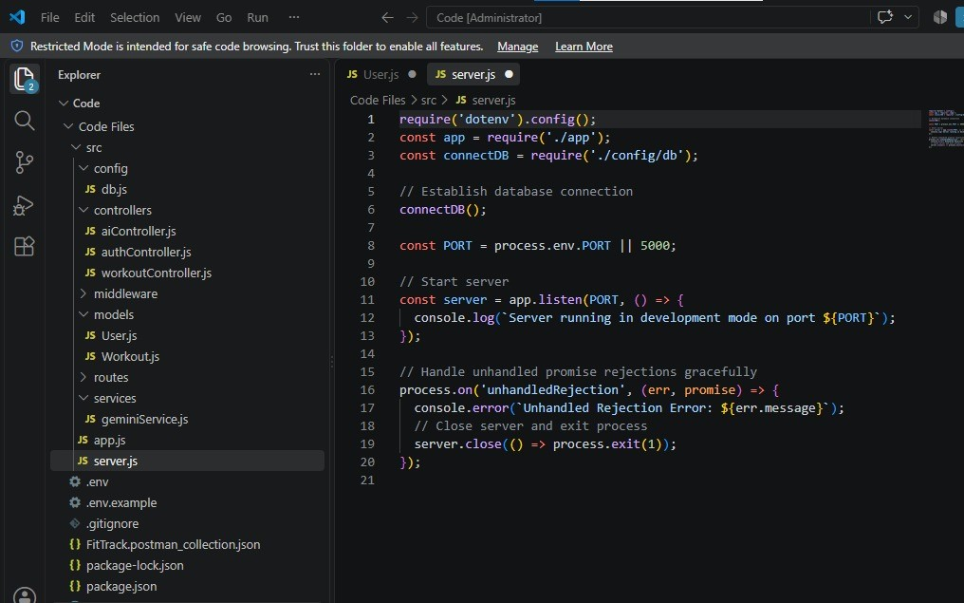
Implementation evidence supplied from the project workspace screenshots.

25. USER MODEL — User.js
Mongoose User schema with name, email, password, validation rules, and timestamps. This matches the User entity described in the database-design section.
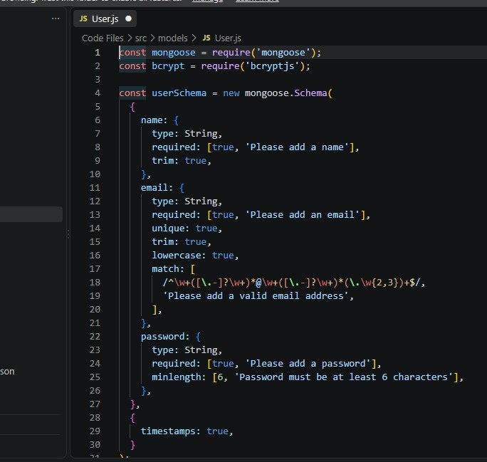
Implementation evidence supplied from the project workspace screenshots.

26. API TESTING — Postman Collection
Postman collection used for API testing, including authentication-related request/test structure.
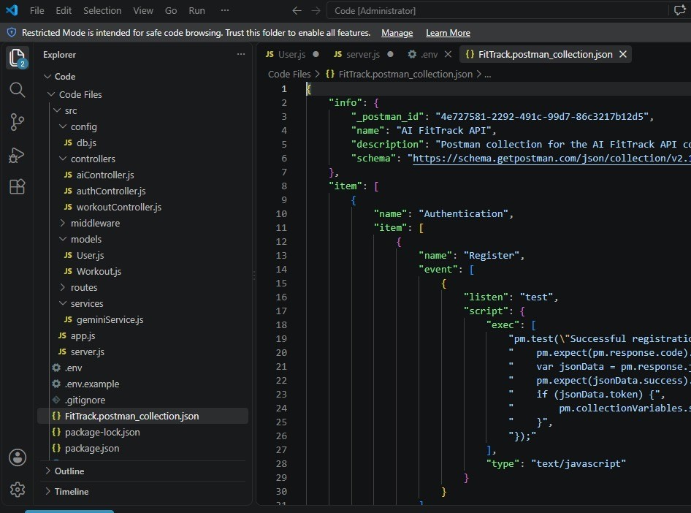
Implementation evidence supplied from the project workspace screenshots.

27. PROJECT DEPENDENCIES — package-lock.json
Installed project dependencies reflected in the Node.js backend setup, including Express, Mongoose, JWT, bcrypt, dotenv, CORS, Morgan, and the Google GenAI package.
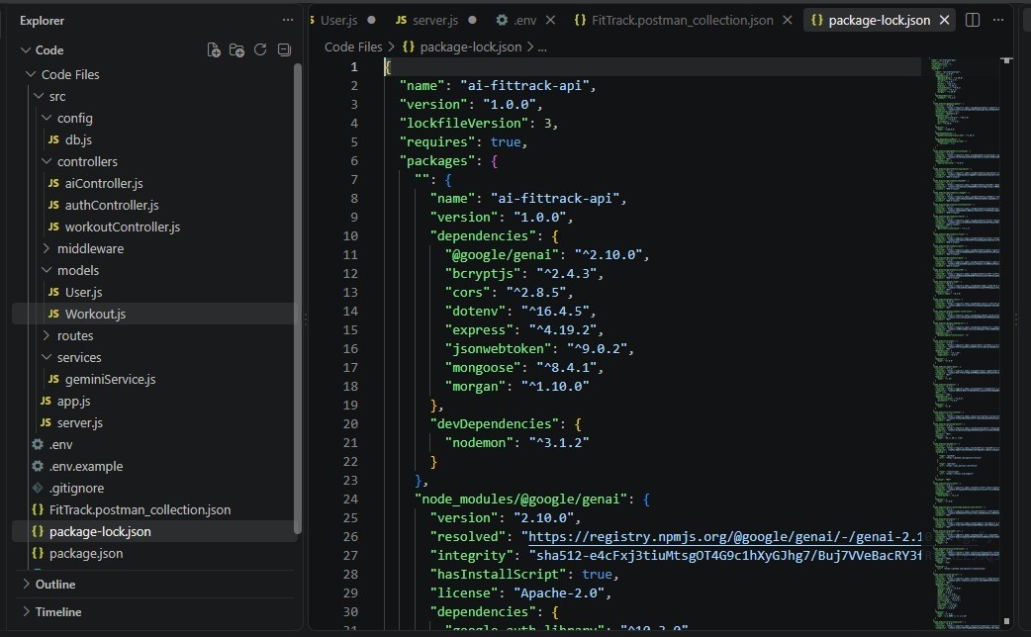
Implementation evidence supplied from the project workspace screenshots.

AI FitTrack API • Project Links
Reference links for the project documentation:

CODE LINK
https://drive.google.com/drive/folders/1-th8i66GnzZ_bJRksakBTEs384z1Mdg3?usp=drive_link

API LINK
https://drive.google.com/file/d/1bC-Uvg-V0kec5gR9poHOw2ib9NEKsdAK/view?usp=drive_link

DEMO LINK
https://drive.google.com/file/d/14X6IGVla7bO0dV04kt6BzdYerpQdhfxG/view?usp=drive_link

THANK YOU

